**Brainstorm & Idea Prioritization**

**Project Title:** Garage Management System

**Team ID**: LTVIP2025TMID31528

**List of team members:**

* Pavan Surya
* Lohitha
* Suryakala

**College Name** : Ideal Institute Of Technology

**1. Ideation Phase**

**Problem Statement:**

Most garages still depend on manual methods to manage operations like vehicle entry, service history, billing, and inventory. This leads to data loss, delays, and inefficient management. The goal is to build a digital solution that streamlines garage operations.

**Key Issues:**

* No real-time tracking of vehicles
* Manual customer and service recordkeeping
* Error-prone billing process
* No spare parts inventory tracking
* Lack of service reminders for customers
* No access control for admin and staff

**System Goal:** To develop a reliable and secure Garage Management System that automates routine tasks, improves customer experience, and increases operational efficiency.

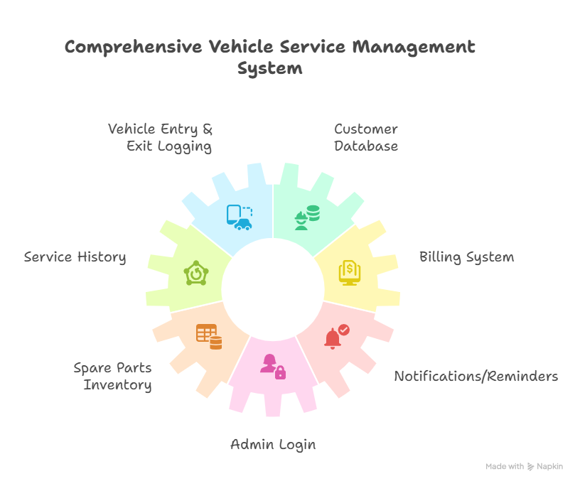

**2. Brainstorm & Idea Prioritization**

To build an efficient Garage Management System, a brainstorming session was conducted to identify all the necessary features that address garage-related problems. These ideas reflect practical needs observed in real-world garages.

**Brainstormed Features:**

* Vehicle entry and exit tracking
* Customer and vehicle database
* Service history management
* Billing and invoice generation
* Spare parts inventory management
* Admin login and role-based access
* Notifications for service reminders
* Report generation (daily, weekly, monthly)

**Prioritization**

**Top Priority Features to Focus On**

* Vehicle Logging
* Customer Database
* Admin Login
* Billing System

|  |  |  |  |
| --- | --- | --- | --- |

| **Next Steps / Action Plan**  Task | Deadline | Tools Needed | Assigned To |
| --- | --- | --- | --- |
| Create login page | 2 days | laptop | Pavan Surya |
| Build vehicle logging module | 3 days | laptop | Suryakala, Lohitha |

**Note**

* You can update the priorities later if new features are added.
* Keep checking with users (garage staff) for feedback.